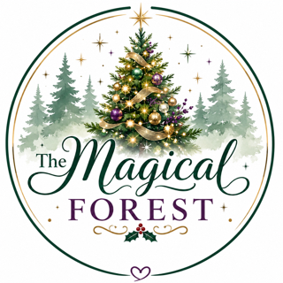

TREE SPONSOR REGISTRATION FORM
Registration Deadline: Friday, October 31, 2026
Tree/Basket Setup:
Festival: Nov. 28 – Dec. 12, 2026
Contact: Janet Seredejko mijen01@comcast.net or Sharon Cross scross@whai.com

Sponsor Information
Organization / Sponsor
Email
Tree/ Basket Title
Contact Person
Cell Phone
Business Phone
May We Text You?
Date

Tree Information
Tree Height: ☐ Tabletop (4' or under) ☐ 5' ☐ 6' ☐ 6.5' ☐ 7' ☐ 7.5' ☐ 8' ☐ 8.5' ☐ 9' ☐ 9.5' ☐ 10' ☐ Other ________
☐ I will provide a tree skirt.
☐ I understand I must provide a TREE BAG for the winner.

Setup Appointment
Preferred setup time:
☐ 9:00–10:00 AM ☐ 10:00–11:00 AM ☐ 12:00–1:00 PM ☐ 1:00–2:00 PM ☐ 2:00–3:00 PM

Gift Information
Will your tree include gift cards, gift certificates, or wrapped gifts?
☐ Yes – I will email a detailed gift list.
☐ No – Everything is on the tree.
☐ No – No gift cards/certificates.
☐ Yes – Wrapped gifts included; I will email a gift list.
Gift List / Notes:
__________________________________________________________________________________________
__________________________________________________________________________________________
__________________________________________________________________________________________

Sponsor Guidelines
- Brand NEW artificial tree (in the box).
- Tabletop space is limited.
- Include a tree skirt.
- Bring any setup supplies you need.
- Provide a tree bag for the winner.
- No perishable items on or under the tree.
- Provide a complete gift list (including gift cards/certificates) if applicable.
- All items displayed with the tree go home with the winning ticket holder.
Thank you for supporting the Light Up the Fairgrounds & Magical Forest!

